# **STUDENT 9 – Digital Health Insurance and Claim Settlement System**

## Case Study Description

This Health Insurance Platform manages policyholders, hospitals, claims, medical

services, assessors, and payments. It automates claim validation and ensures

accurate and timely reimbursements for insured clients.

## Tables to Create

### InsuranceCompany (CompanyID, Name, Category, Address, Contact, Email, LicenseNumber)

### Plan (PlanType, PlanLimit)

### PolicyHolder(HolderID, FullName, Contact, NationalID, PlanType, JoinDate)

### Hospital (HospitalID, Name, Address, Contact, Type)

### Assessor (AssessorID, FullName, Department, Contact, Region)

### Claim (ClaimID, HolderID, HospitalID, DateFiled, AmountClaimed, Status)

### Service (ServiceID, ClaimID, Description, Cost, ServiceDate)

### Payment (PaymentID, ClaimID, AssessorID, Amount, PaymentDate, Method)

## Relationships

* PolicyHolder → Claim (1:N)
* Hospital → Claim (1:N)
* Claim → Service (1:N)
* Claim → Payment (1:1)
* Assessor → Payment (1:N)

## Here is the Tasks to Perform and their screenshot results

1. Create Database
2. Create all tables with data validation and referential integrity rules.
3. Apply CASCADE DELETE between Claim → Service.
4. Insert 5 hospitals, 10 policyholders, and 10 claims.
5. Retrieve total approved claim amounts per hospital.
6. Update payment records after approval.
7. Identify hospitals with the highest claim frequency.
8. Create a view summarizing claim settlements by assessor.
9. Implement a trigger that rejects claim insertion if amount exceeds plan

## Here is the screenshot of the different task performed

### Create Database screenshot

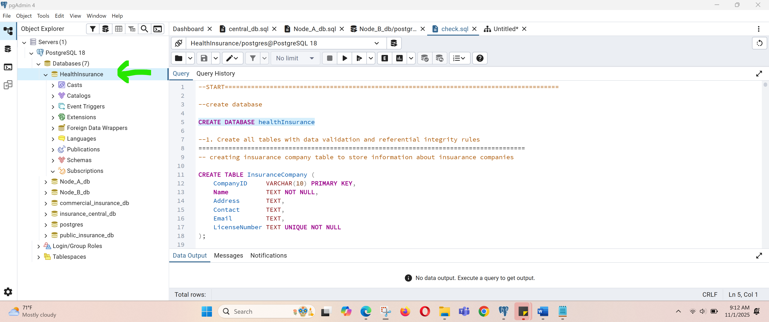

### Create all tables with data validation and referential integrity rules.

#### InsuranceCompany table

#### 

#### Plan table

#### 

#### PolicyHolder table

#### 

#### Hospital table

#### 

#### Assessor

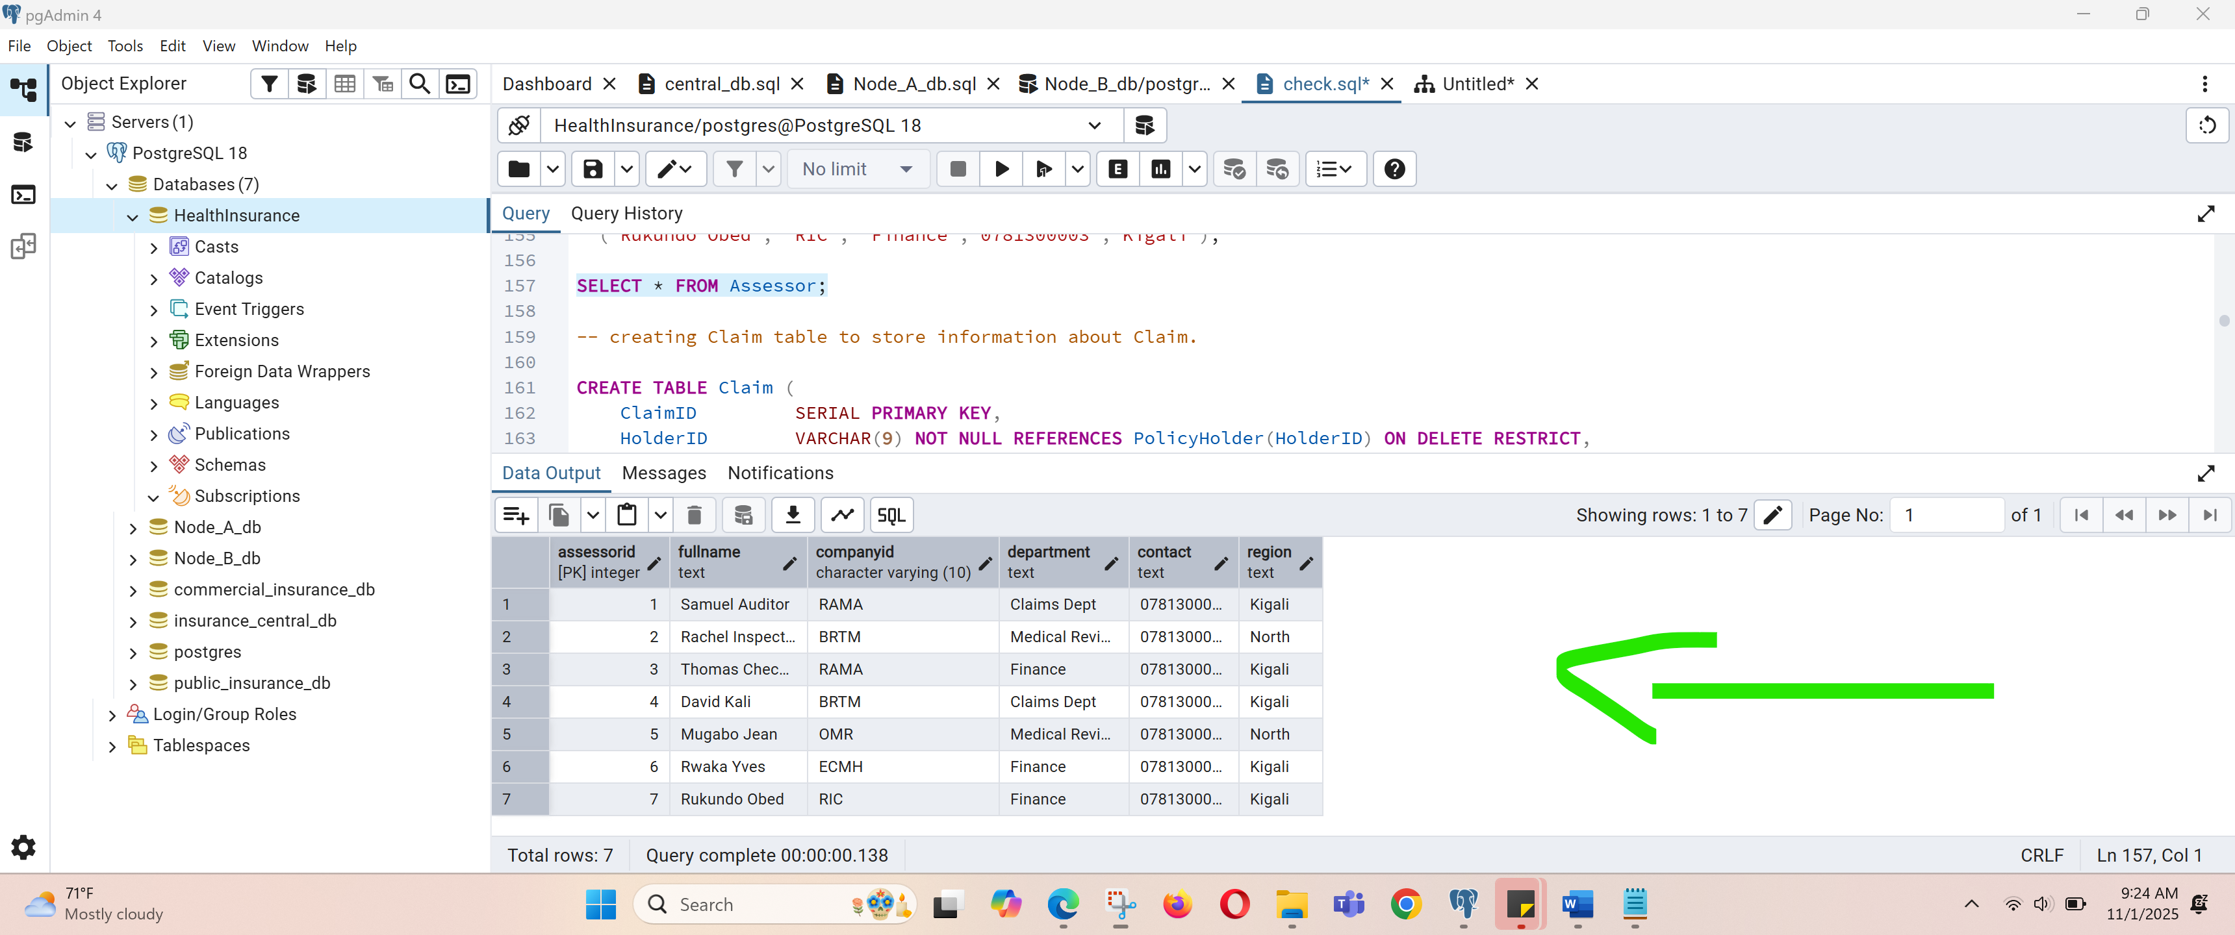

#### Claim

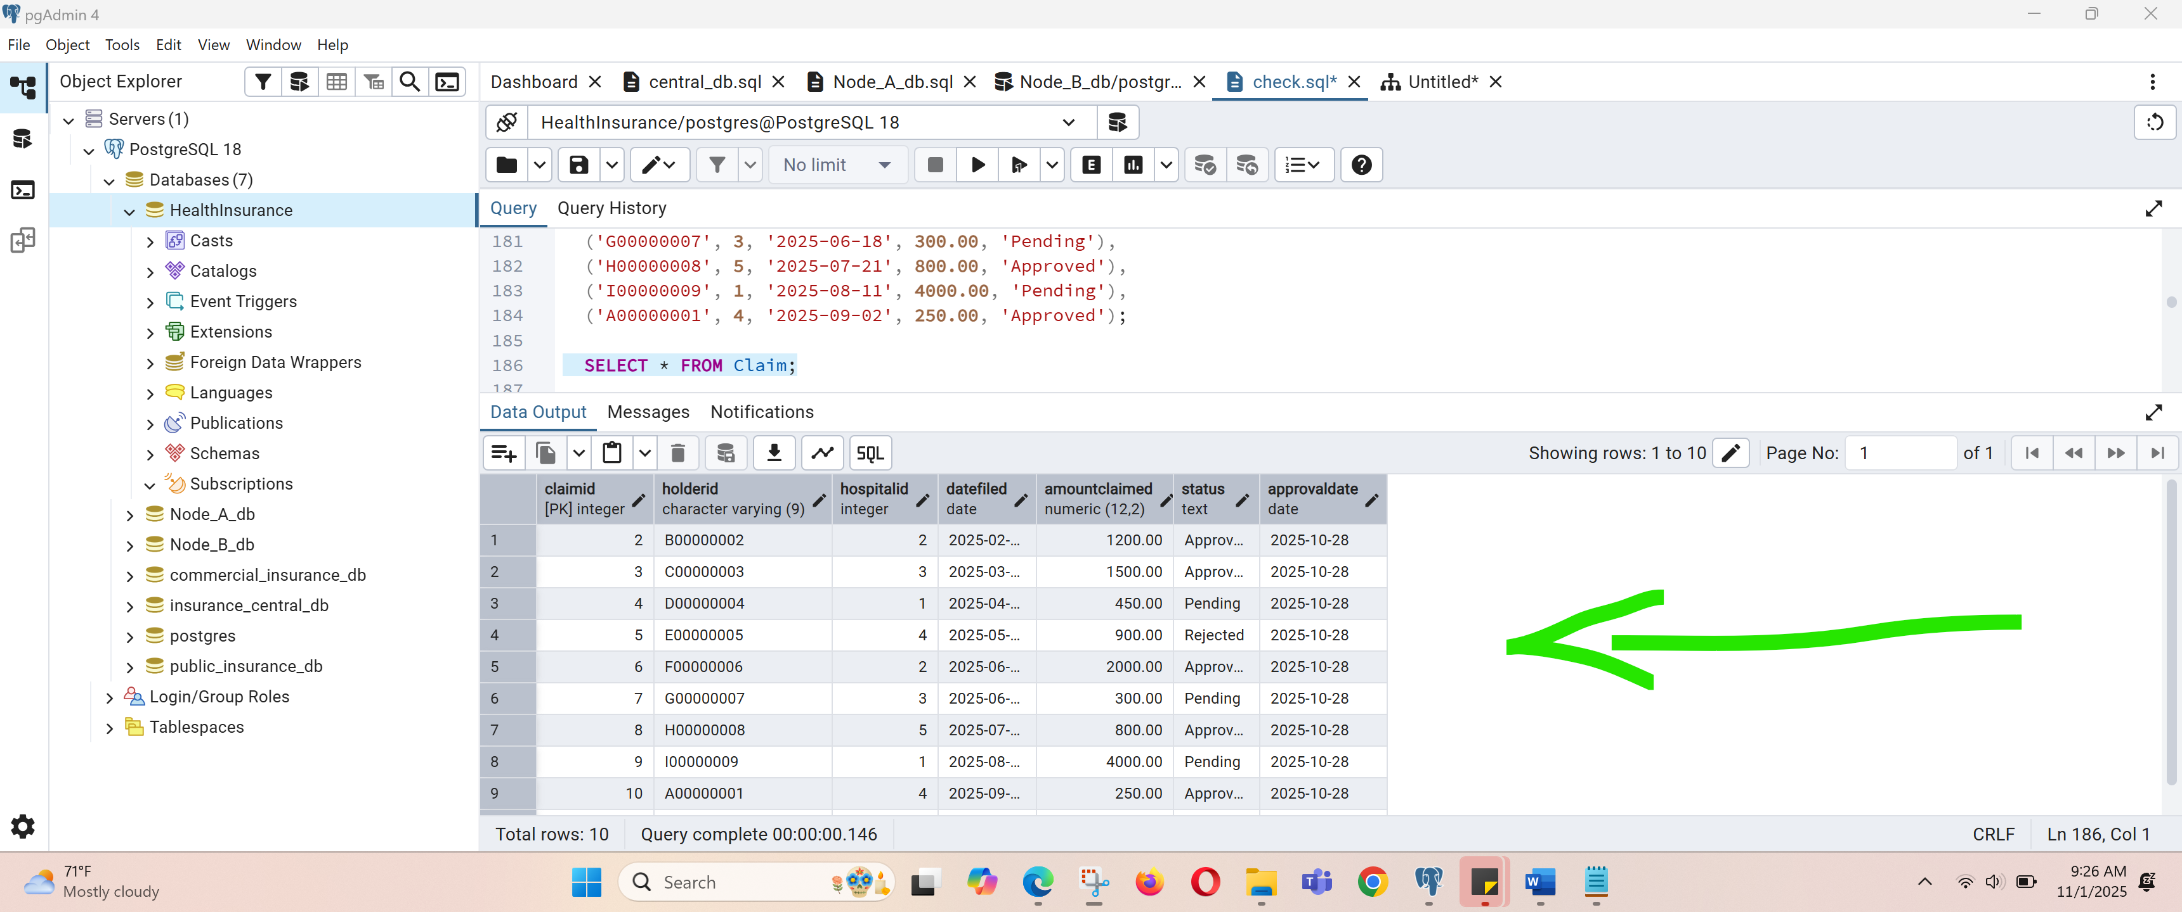

#### Service

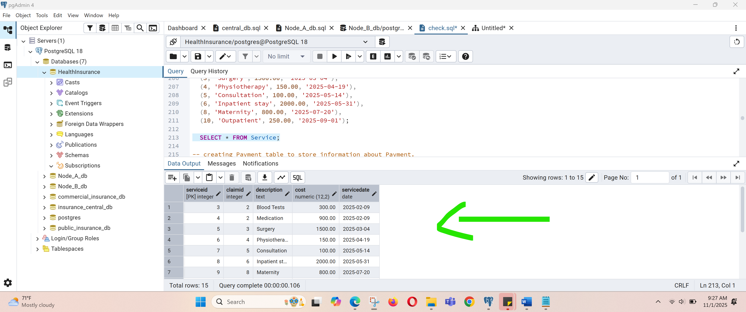

#### Payment

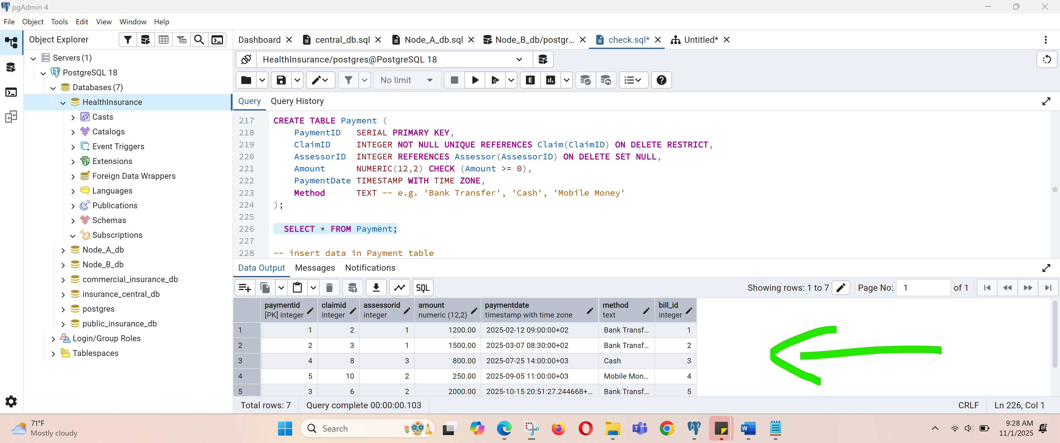

### Apply CASCADE DELETE between Claim → Service.

This means each Service record is linked to exactly one Claim. (Every service belongs to a claim.)

“If a Claim is deleted, automatically delete all Service records that reference it.”

Example:

Service records before Cascading Deletion: there are record where “claimID is 4” as this screenshot shows.

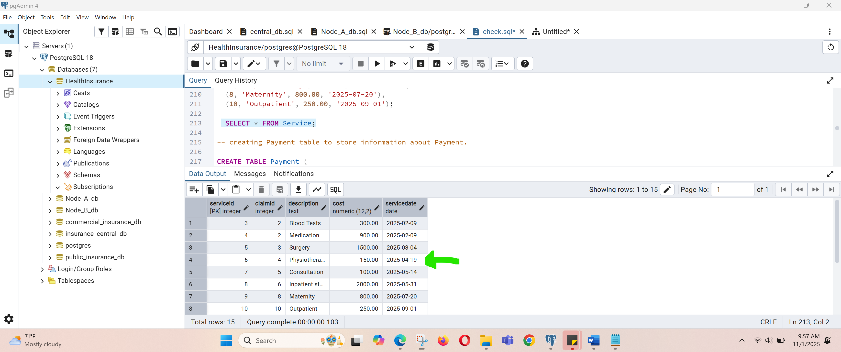

CREATE TABLE Service (

ServiceID SERIAL PRIMARY KEY,

ClaimID INTEGER NOT NULL REFERENCES Claim(ClaimID) ON DELETE CASCADE,

Description TEXT NOT NULL,

Cost NUMERIC(12,2) NOT NULL CHECK (Cost >= 0),

ServiceDate DATE NOT NULL

);

--This means each Service record is linked to exactly one Claim.

--(Every service belongs to a claim.)

--“If a Claim is deleted, automatically delete all Service records that reference it.”

--Exmple:

DELETE FROM Claim WHERE ClaimID = 4; -- these will dellete two records in services table referenced by ClaimID = 4)

Service records after Cascading Deletion: shows that the record where “claimID is 4” is deleted as this screenshot shows.

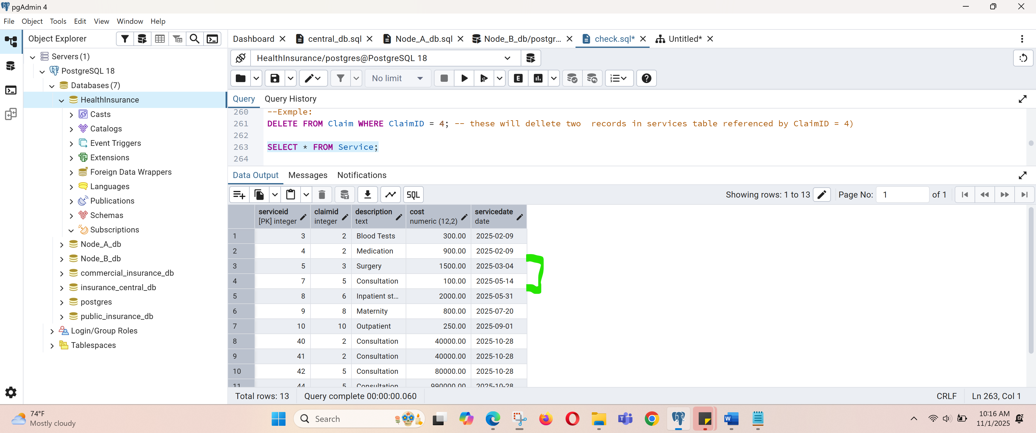

### Insert 5 hospitals, 10 policyholders, and 10 claims.

#### Insert 5 hospitals

-- insert data in Hospital table

INSERT INTO Hospital(Name, Address, Contact, Type) VALUES

('Rwanda Central Hospital', 'Kigali - Nyarugenge', '0781000001', 'Public'),

('Green Valley Clinic', 'Kigali - Gasabo', '0781000002', 'Clinic'),

('Mountain View Medical Centre', 'Kigali - Kicukiro', '0781000003', 'Private'),

('RiverSide Hospital', 'Kigali - Remera', '0781000004', 'Private'),

('St. Mary Community Hospital', 'Kigali - Nyamirambo', '0781000005', 'Public'),

('La Polyfame Hospital', 'Kigali - Nyamirambo', '0781000005', 'Private'),

('Muhima Hospital', 'Kigali - Nyarugenge', '0791000005', 'Public'),

('Masaka Hospital', 'Kigali - Masaka', '0781000040', 'Public');

-- fetch data from insuarance company table

SELECT * FROM Hospital;

1. Retrieve total approved claim amounts per hospital.
2. Update payment records after approval.
3. Identify hospitals with the highest claim frequency.
4. Create a view summarizing claim settlements by assessor.
5. Implement a trigger that rejects claim insertion if amount exceeds plan

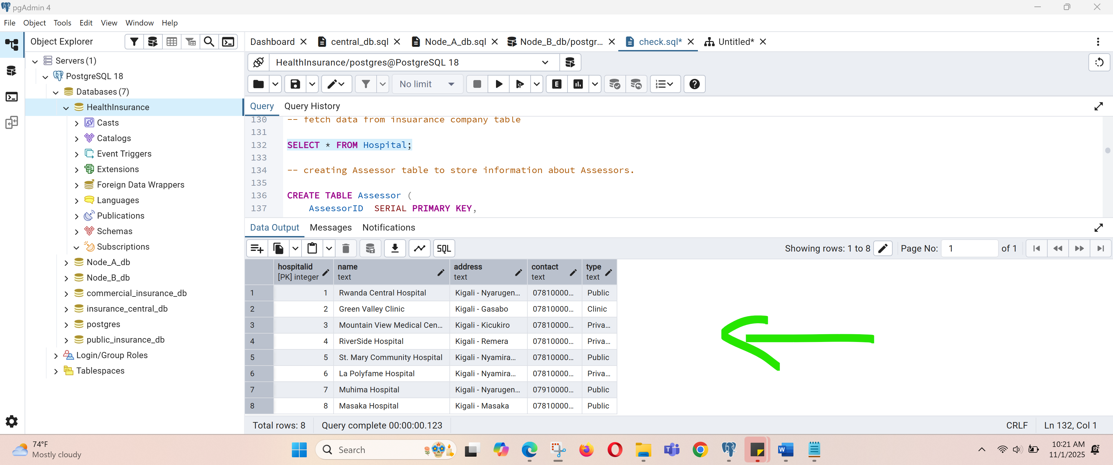

#### 2. policyholders

-- insert data in PolicyHolder table

INSERT INTO PolicyHolder(HolderID, FullName, Contact, NationalID, PlanType, CompanyID, JoinDate) VALUES

('A00000001', 'Alice Uwase','0781210001','1198680184134041','Basic', 'RAMA', '2024-01-15'),

('B00000002', 'Bob Nkurunziza','0781210002','1198880184134061','Standard', 'RAMA', '2023-06-10'),

('C00000003', 'Charlie Mukamana','0781210003','1197680184134141','Premium', 'BRTM', '2022-09-01'),

('D00000004', 'Diane Habimana','0781210004','1198980184134041','Standard', 'RAMA', '2025-02-20'),

('E00000005', 'Elias Uwitonze','0781210005','1200380184131041','Basic', 'OMR', '2024-11-01'),

('F00000006', 'Faith Kagabo','0781210006','1201380184131061','Premium', 'ECMH', '2023-03-03'),

('G00000007', 'George Manzi','0781210007','1200380184131071','Standard', 'RAMA', '2021-12-12'),

('H00000008', 'Hannah Mukaruriza','0781210008','1200380184181041','Basic', 'ECMH', '2022-05-05'),

('I00000009', 'Ivan Byiringiro','0781210009','1200380194131041','Premium', 'RIC', '2020-08-08'),

('J00000010', 'Joyce Karekezi','0781210010','1200380183131041','Standard', 'RIC', '2024-07-07');

-- fetch data from insuarance company table

SELECT * FROM PolicyHolder;

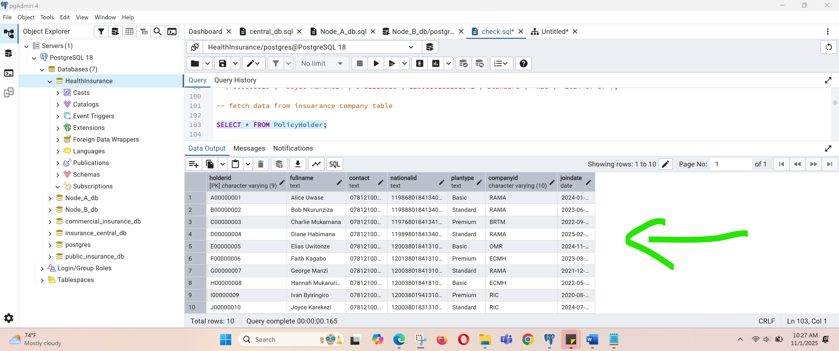

### Retrieve total approved claim amounts per hospital.

-- 5--. Retrieve total approved claim amounts per hospital.

-- ======================================================

-- This query sums AmountClaimed for Claims with Status='Approved', grouped by hospital

SELECT h.HospitalID, h.Name,

COUNT(c.ClaimID) AS approved_claim_count,

SUM(c.AmountClaimed) AS total_approved_amount

FROM Hospital h

LEFT JOIN Claim c ON c.HospitalID = h.HospitalID AND c.Status = 'Approved'

GROUP BY h.HospitalID, h.Name

ORDER BY total_approved_amount DESC NULLS LAST; ('H00000008', 'Hannah Mukaruriza','0781210008','1200380184181041','Basic', 'ECMH', '2022-05-05'),

('I00000009', 'Ivan Byiringiro','0781210009','1200380194131041','Premium', 'RIC', '2020-08-08'),

('J00000010', 'Joyce Karekezi','0781210010','1200380183131041','Standard', 'RIC', '2024-07-07');

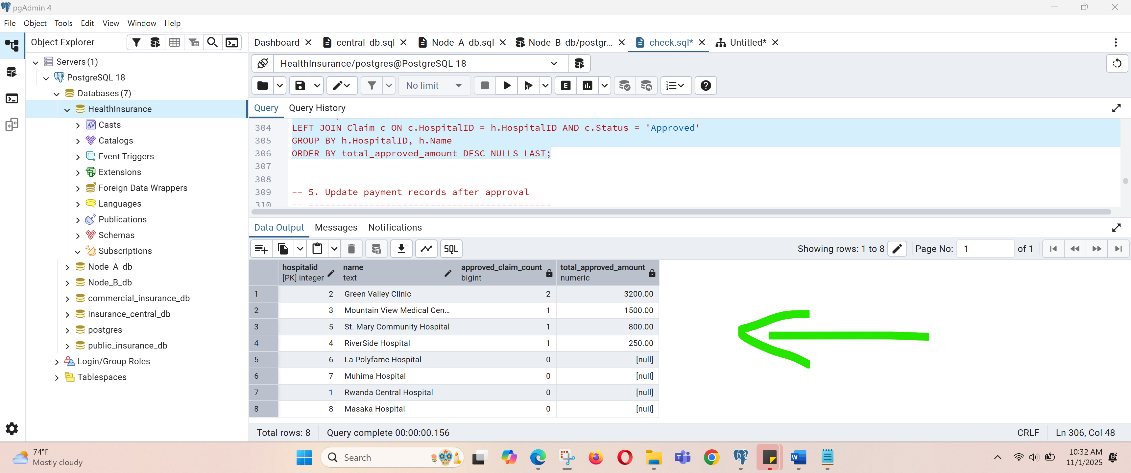

### Update payment records after approval.

-- 5. Update payment records after approval

-- ============================================

-- Eg: for approved claims that have a payment row with NULL amount, set payment to claim amount and mark payment date + method.

-- Update existing payment rows associated to claims that are 'Approved' and currently have NULL Amount.

UPDATE Payment p

SET Amount = c.AmountClaimed,

PaymentDate = now(),

Method = COALESCE(p.Method, 'Bank Transfer')

FROM Claim c

WHERE p.ClaimID = c.ClaimID

AND c.Status = 'Approved'

AND p.Amount IS NULL;

-- If there are approved claims without any payment row at all, create payment rows (example: create payments for all approved claims missing payments)

INSERT INTO Payment (ClaimID, AssessorID, Amount, PaymentDate, Method)

SELECT c.ClaimID, -- choose a default assessor or NULL

1 AS AssessorID,

c.AmountClaimed,

now(),

'Bank Transfer'

FROM Claim c

LEFT JOIN Payment p ON p.ClaimID = c.ClaimID

WHERE c.Status = 'Approved'

AND p.ClaimID IS NULL;

### Identify hospitals with the highest claim frequency.

-- 6. Identify hospitals with the highest claim frequency

======================================================

-- Show counts, sorted descending; to include ties we can use RANK()

======================================================

SELECT h.HospitalID, h.Name,

COUNT(c.ClaimID) AS claim_count

FROM Hospital h

LEFT JOIN Claim c ON c.HospitalID = h.HospitalID

GROUP BY h.HospitalID, h.Name

ORDER BY claim_count DESC;

-- To show the top hospital(s) including ties:

WITH counts AS (

SELECT h.HospitalID, h.Name, COUNT(c.ClaimID) AS claim_count

FROM Hospital h

LEFT JOIN Claim c ON c.HospitalID = h.HospitalID

GROUP BY h.HospitalID, h.Name

)

SELECT * FROM counts

WHERE claim_count = (SELECT MAX(claim_count) FROM counts);

### Create a view summarizing claim settlements by assessor.

-- 7. Create a view summarizing claim settlements by assessor

==========================================

-- The view shows assessor name, number of payments they processed, total paid, average paid, last payment date.

CREATE OR REPLACE VIEW vw_assessor_claim_settlements AS

SELECT a.AssessorID,

a.FullName AS AssessorName,

COUNT(p.PaymentID) AS payments_processed,

COALESCE(SUM(p.Amount), 0) AS total_paid,

COALESCE(AVG(p.Amount), 0) AS avg_payment,

MAX(p.PaymentDate) AS last_payment_date

FROM Assessor a

LEFT JOIN Payment p ON p.AssessorID = a.AssessorID

GROUP BY a.AssessorID, a.FullName;

-- Example usage:

SELECT * FROM vw_assessor_claim_settlements ORDER BY total_paid DESC;

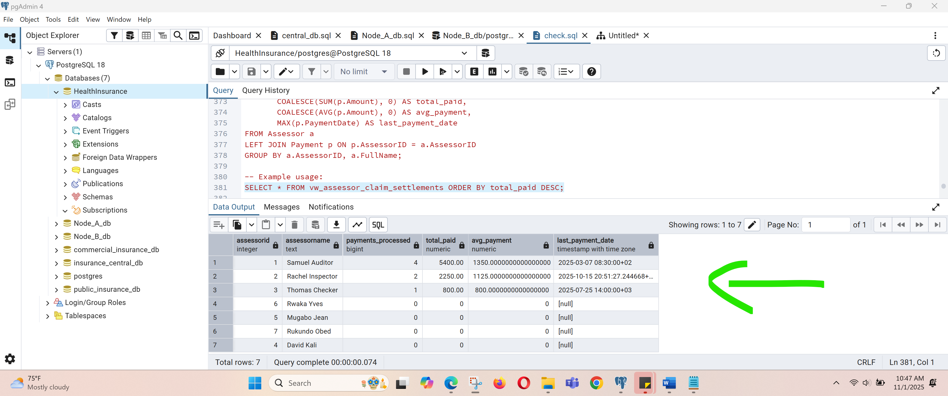

### Implement a trigger that rejects claim insertion if amount exceeds plan

--8--. Implement a trigger that rejects claim insertion if amount exceeds plan limit.

======================================================

CREATE OR REPLACE FUNCTION fn_check_claim_within_plan_limit()

RETURNS TRIGGER AS $$

DECLARE

allowed NUMERIC;

BEGIN

-- Get plan limit for the policyholder

SELECT p.PlanLimit INTO allowed

FROM PolicyHolder ph

JOIN Plan p ON ph.PlanType = p.PlanType

WHERE ph.HolderID = NEW.HolderID;

IF allowed IS NULL THEN

RAISE EXCEPTION 'Policy holder % has no plan or plan not found', NEW.HolderID;

END IF;

IF NEW.AmountClaimed > allowed THEN

RAISE EXCEPTION 'Claim rejected: amount (%.2f) exceeds plan limit (%.2f) for holder %', NEW.AmountClaimed, allowed, NEW.HolderID;

END IF;

RETURN NEW;

END;

$$ LANGUAGE plpgsql;

CREATE TRIGGER trg_claim_within_limit

BEFORE INSERT ON Claim

FOR EACH ROW EXECUTE FUNCTION fn_check_claim_within_plan_limit();

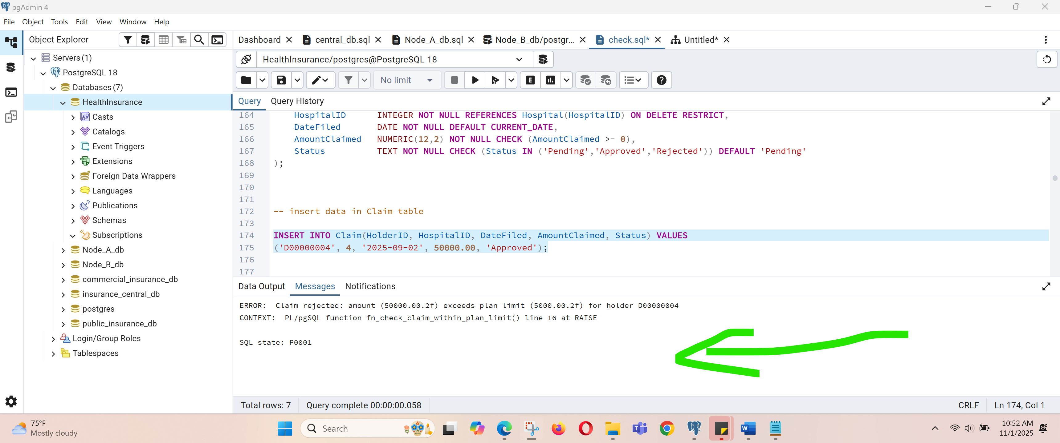

h